NVEffects Sample Descriptions
And Effects Browser Framework

Please send comments/questions/suggestions to
Christopher Maughan (cmaughan@nvidia.com)

Introduction
This document outlines the NVEffects vertex/pixel shading samples. Some of the samples are designed to demonstrate simple techniques, such as transform, lighting, texture coordinate generation, and texture coordinate transformation. Others are intended to show the vast possibilities that vertex and pixel shaders enable. Some samples have been modified from existing SDK demos to show the advantages of using a programmable vertex shader over the traditional fixed-function T&L. The samples are designed to be educational, and provide inspiration for the uses of programmable shaders. It is easy to extract sections of vertex or pixel shader code and combine them to develop new shaders.

Some of the examples require hardware cube map support, though most should run on any modern multi-texturing graphics card. The minimum recommended graphics card is a GeForce 256 equivalent.

Implementation
All examples are built on a simple framework which shows the current vertex or pixel shader in a pane on the left along with the resulting demo in a pane on the right. The various shaders are selectable from the list in the left-most window. Some shaders have custom menu options accessed by right-clicking the 3D window or using the main menu bar. The NVEffectsBrowser searches its subdirectories for executable shader .dll files. We often release new shaders with source code, and all you have to do to run them is copy the new .dll and associated files into the Effects subdirectory.

All samples are built on DirectX 8. They make extensive use of the DX8 API and use various features of it and the D3DX helper APIs for more clear and concise display of objects.

Each demo is contained in a directory with its own source files. Look in the Effects subdirectory to see all related source code files.

Building the effects
The effects projects were created with Microsoft’s Visual Studio® (C++) 6.0. Each effect may rely on shared assets or code included with the NVEffectsBrowser package. Each effect project file (.dsp) should be two subdirectories down from the NVEffectsBrowser.dsp root location. For example:

NVEffectsBrowser <dir>
NVEffectsBrowser.exe / .dsp
Effects <dir>
Quad <dir>
Quad.dsp
Quad.cpp… etc.
Media <dir>

Source files often have a directory path at the very beginning. Use this as a guide for the correct relative path (The listed absolute path is irrelevant, and will vary from project to project, but the paths should match starting from their first common directory on down). Each effect compiles to a .dll which must live in a directory somewhere beneath the NVEffectsBrowser. You can also load the NVEffectsBrowser workspace file (.dsw) in the root directory and do a ‘batch’ build to compile all the shaders you have downloaded. Of course, you must also build the effects browser to launch the effects.

Table Of Contents

Introduction 1
Implementation 1
Building the effects 1
Table Of Contents 2
1. Spinning Quad and Spinning Quad With Specular 4
2. DX7 Point Light 5
3. DX7 Directional Light 6
4. Many Point Lights 7
5. Two-Sided Lighting 8
6. Fish-Eye lens 9
7. Sine Wave Perturbation 10
8. Cube Mapping 11
9. Mesh Blending 12
10. Layered Fog 13
11. Dot 3 Bump Directional Light 14
12. Dot 3 Bump Point Light 15
13. Motion Blur 16
14. Particle System 17
15. Blinn Bump Reflection 18
16. Bump Environment Map Bump-Mapping 19
17. Clip-Planes with Texkill 20
18. Toon Shading 21
19. Filter Blitting 22
20. Two-Sided Texturing 23
21. Depth of Field 24
22. Rainbow Rendering 26
23. Anisotropic Rendering 27
24. Single Pass Reflection and Refraction 28
25. Membrane lighting 29
26. Perlin Noise Generation 30
27. Keyframe Interpolation 31
28. Matrix Palette Skinning w/ Dot3 32
29. Minnaert Lighting 33
30. NVLINK 1.0 34
31. Silhouette Rendering 35
32. Simple Fog Example 36
33. Game of Life 37



Spinning Quad and Spinning Quad With Specular
This sample draws a single spinning Quadrangle in the center of the viewport. The shader program executes in 7 instructions for one vertex. First, it transforms the input vertex by a model-view-projection matrix stored in the constant registers. This value is output as the vertex position. Second, it sets the output color based on the dot product of the vertex normal with the eye vector. This is one of the simplest lighting calculations to do. To save the normal transform into eye-space, the light vector is supplied in model space. Third and last, it copies the texture coordinates.

Demonstrates: Simple transformation and dot product lighting in model space

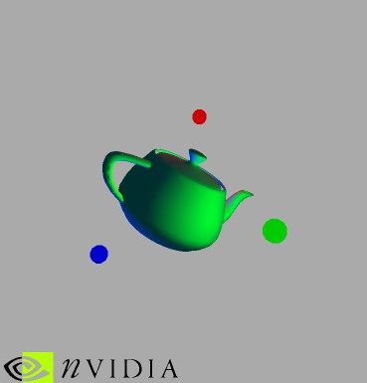

DX7 Point Light
The shader lights in eye-space, it also calculates a half-vector between the light and the eye, using a local viewer. This shader used the LIT instruction to correctly clamp the dot product/normal value and calculate a power function from the half-vector/normal dot products created in the shader. The shader also calculates constant, linear and quadratic attenuation using the DST instruction to speed up the calculation. The result is 3 different point lights with specular highlights and distance attenuation. This light is implemented in a similar way to a DirectX 7 point light.

Demonstrates: Use of the ‘LIT’, ‘DST’ instructions, Specular/Diffuse lighting, half-vector calculation, local viewer lighting, and attenuation

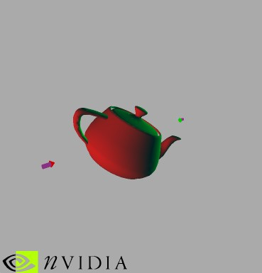

DX7 Directional Light
This shader implements a directional light in the same style as a DirectX 7 directional light. The shader lights in eye space. The viewer is assumed to be an infinite distance away, hence a constant half-vector is used. The LIT instruction is also used to correctly clamp the dot product/normal value and calculate a power function from the half-vector/normal dot products calculated in the shader. The result is a directional light with a specular highlight, two of which are implemented in the shader.

Demonstrates: Use of the LIT instruction, Specular/Diffuse lighting, half-vector calculation, non-local viewer lighting.



Many Point Lights
Because of the large amount of storage available in the constant memory, we can use it to enable more lights than were previously possible. This example creates 17 point-light sources, using a very simple diffuse lighting model. Each light is calculated using just 7 instructions. A macro enables easy placement of each light calculation in the shader. The resulting instruction count is 126 – very near the maximum storage space available.

Demonstrates: Simple point lighting. Use of the MAX instruction for clamping each light calculation

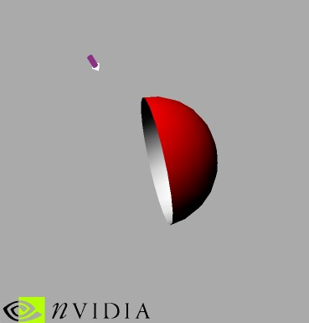

Two-Sided Lighting
This sample uses non-indexed triangle lists. Each vertex contains not only a vertex normal for correct lighting, but also a face-normal. The face normal is checked against a vector to the eye. The dot product of these two vectors indicates whether the face is oriented towards or away from the eye. Based on this assessment the shader sets up the material color to be one of two options for front and back facing materials. The example also does the lighting calculation in eye space and therefore transforms the normal vector to eye space and normalizes it before use.

Demonstrates: Conditional code without branching, Directional lighting in Eye Space, unusual usage of input streams.
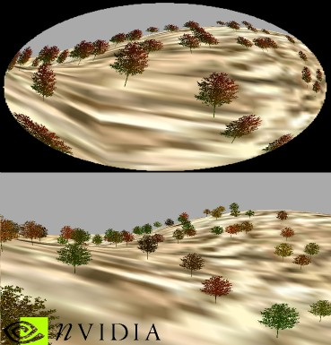

Fish-Eye lens
This example transforms a vertex into eye space and applies a distortion to it. The distortion formula is loosely based on the formula to be found on: “www-cad.eecs.berkley.edu/Respep/Research/interact/playpen/fish”. A variation of this formula is used to calculate a vertex distortion in eye-space. This is then applied to all the geometry in the scene.

The lower image demonstrates the original scene, the upper image is the same scene with the distortion applied – giving an effective fish-eye lens effect.
Because the lighting of the terrain is slightly different to the trees, two different shaders are used, though they both apply the same distortion calculation.

The menu option allows to toggle wire-frame rendering.

Demonstrates: Irregular transform, use of MAX instruction for performing an ABS operation.
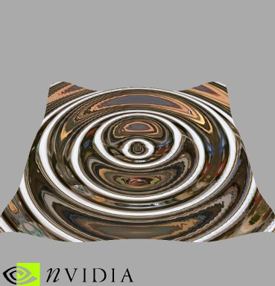

Sine Wave Perturbation
A flat grid of polygons is deformed by a sine wave, sampled from the constant memory using a Taylor series. The shader calculates the first 4 values in the series. The distance from the center of the grid is used to generate a height, which is applied to the vertex coordinate. A normal is also generated and used to generate a texture coordinate reflection vector from the eye, which looks into a cubic environment map.

The input data for this shader is simply 2 floating-point values. The shader generates all normal, texture and color information itself.

The menu-option allows rendering in wire frame, and left clicking allows rotating the mesh.

Demonstrates: Calculation of approximate sine/cosine values using a Taylor series. Generation of normals, texture coordinate generation.
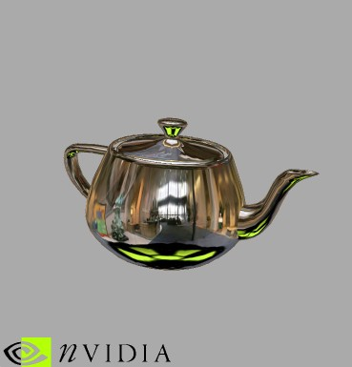

Cube Mapping
Cube maps have various uses. This shader demonstrates how to generate a texture coordinate for use with environment cube maps. The input normal vector and the eye-space vertex are used to calculate a reflection vector. This vector is loaded into the texture coordinates for use by the rasterizer in drawing the reflected object with a cube map. As can be seen, the object accurately reflects its surroundings.

After calculating a vector to the eye and a normal, the shader does a simple reflection calculation (4 instructions) – note that this example gives true local-viewer reflections into the cube map.

Demonstrates: Texture generation for cubic environment map reflections.
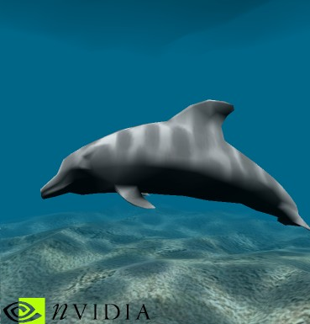

Mesh Blending
The Mesh Blending shader implements blending/morphing between two input meshes. The meshes and their normals are blended in model-space before being transformed and lit in eye-space. In this case the weights are supplied in constant memory and change each frame to cause the dolphin to wave its tail. There is nothing to stop the weights being passed into the shader on a per-vertex basis, if required. A more advanced form of mesh blending could use several matrices and ‘pick’ the correct set from a list in constant memory, based on settings in the input stream (this technique is often referred to as ‘matrix palette skinning’). This sample also generates procedural texture coordinates, based on the eye vertex position. These are used to lookup the caustic texture applied to the top of the dolphin.

This shader also lights the dolphin from above using a directional light. In this case, the alpha channel is set to contain the intensity of the light. This enables the texturing pass to apply the caustic texture and the dolphin skin to the lit dolphin in a single dual-texture pass, using a pre-modulate texture blend mode and two texture stages. The original DirectX SDK sample required two passes to draw the dolphin – here the vertex shader has been used to simplify the rest of the pipeline by a very simple modification to the lighting pipeline, previously impossible with fixed-function T&L.

Demonstrates: Mesh blending, multiple input coordinates, modified lighting calculation
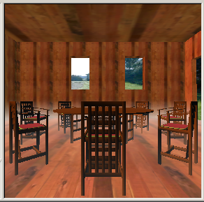

Layered Fog
This shader implements layered fog. The concept of layered fog is quite simple; the fog intensity is a function of height above the ground as well as distance from the viewer. The sample first generates a texture map containing a 2D lookup function. The vertex shader then calculates the distance from the viewer and the height of the viewer above the ground for each vertex and uses these values to setup the texture coordinates. The texture coordinates then index the fog map texture and this is applied as a second texture pass to each of the polygons.

Demonstrates: Texture coordinate generation, directional lighting

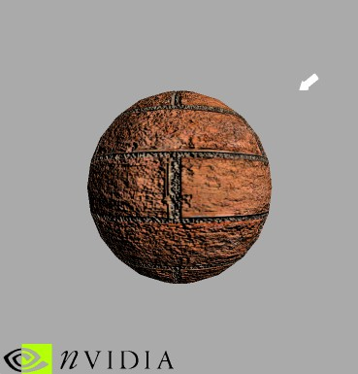

Dot 3 Bump Directional Light
This shader implements the per-vertex setup required to rotate a light vector in to texture space. The setup code first sets up 3 basis vectors – S, T and SxT. These only change when the mesh is modified. During vertex shading the directional light vector is rotated into texture space and stored in the diffuse vertex color. The matrix to do the rotation is calculated by transforming the basis vectors into world space and combining them to form a rotation matrix.

Later, in the texture stages, the vertex color is combined with the normal map to create the bumpy surface. A second texture stage then applies the base texture image to complete the effect.

The menu options allow the display of the bumpmap, the light vector that is calculated by the vertex shader, and the base texture.

Demonstrates: Dot3 bumpmapping setup in hardware.

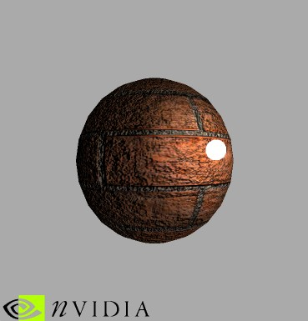

Dot 3 Bump Point Light
This shader computes a local, attenuated light-vector and transforms it with the basis vectors passed into the shader. As with the directional dot3 light example (see above) the setup code first sets up 3 basis vectors – S, T and SxT. These only change when the mesh is modified. During vertex shading the local light vector is rotated into texture space and stored in the diffuse vertex color. The matrix to do the rotation is calculated by transforming the basis vectors into world space and combining them to form a rotation matrix.

Later, in the texture stages, the vertex color is combined with the normal map to create the bumpy surface. A second texture stage then applies the base texture image to complete the effect.

The menu options allow the display of the bumpmap, the base texture, the attenuation, the normalized texture space light vector, the bumped light, the bumped light with the base texture, or all the effects combined..

Demonstrates: Dot3 bumpmapping setup for attenuated point lights in hardware.

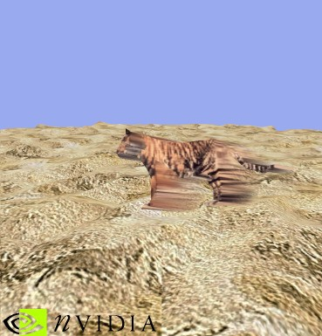

Motion Blur
This shader creates a smooth motion-blur effect in two passes. The first pass draws the object normally. The second pass transforms each vertex both with the current frame’s transform as well as with the previous frame’s transform. The difference between these two points is a per-vertex motion vector. If the dot product of this motion-vector with the vertex-normal is positive, then the vertex faces into the direction of motion and we transform and light it normally. If, however, this dot product is negative, then the vertex faces away from the direction of motion and we transform it with the previous frame’s transform. We therefore stretch the object from its old position to its new position on the screen. To enhance the motion-blur look, we also modulate the alpha-component of the diffuse color of vertices facing away from the direction of motion by the length of the motion-vector.

The menu options allow toggling the motion-blur effect, increasing object speed, pausing the demo, artificially lengthening (or shortening) the motion-blur trail, or rendering in wire frame.

Demonstrates: Conditional code without branching, unusual transform use.

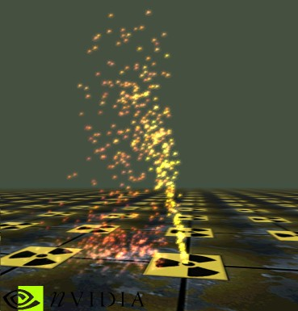

Particle System
This shader creates a particle system that executes exclusively on the GPU. After creating particles in a vertex-buffer, the CPU never touches any vertex ever again!

Each vertex corresponds to a single particle that is displayed as a point-sprite. It stores in its per-vertex data various particle parameters, such as when it is first born, its lifetime, its air-resistance, its initial velocity, one half of a random number seed, as well as its initial color. The vertex shader evaluates a closed-form function that computes a particle’s current position based on the current time (passed in through constant memory), initial particle velocity, particle air-resistance etc. A particle’s initial direction is randomized through a combination of its random number seed and a random number seed from constant memory. Color and fog-values are modulated based on the age of a particle. The sprite-point size depends on the perspective camera-distance.

The menu options allow freezing time and limiting the number of drawn particles to ten, as well as rendering in wire frame. Left-clicking and moving the mouse changes the camera orientation and the arrow-keys move the camera around.

Demonstrates: Conditional code without branching, use of the oFog parameter, use of sprite-point size, use of the address-indexing register a0, calculation of approximate sine values using a Taylor series, and generation of position data from extremely unusual per-vertex data.

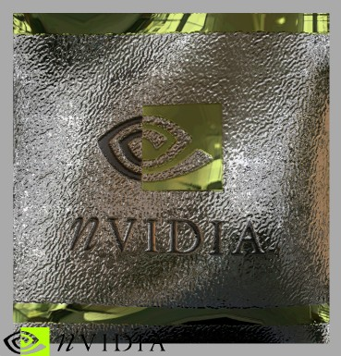

Blinn Bump Reflection
This shader implements reflective Blinn Bump mapping. At set-up time it computes and stores per-vertex S and T basis-vectors. Rendering then commences in two passes: in the first pass the vertex shader computes the S and T cross product and creates a rotation matrix from the S, T, and SxT vectors. This rotation matrix is applied in the pixel shader to the per-pixel normal read from a bump map. The eye-vector is then reflected on the rotated per-pixel normal and then used to look up the reflected color from an environmental cube-map. The second pass modulates the reflected color with a gloss map. The example optionally uses the HILO texture format.

The menu options allow switching between the HILO and 8bit signed texture formats, and showing the effect on either an animated Bezier-patch or a sphere. Additionally, you can change the height of the bumps and start-stop the animation. The mouse can be used to rotate the object.

Demonstrates: Blinn Bump reflection setup in hardware, vertex shader setup for pixel shaders.



Bump Environment Map Bump-Mapping
This shader implements bump environment-map (BEM) bump mapping by using a pixel shader.

Demonstrates: BEM bump-mapping

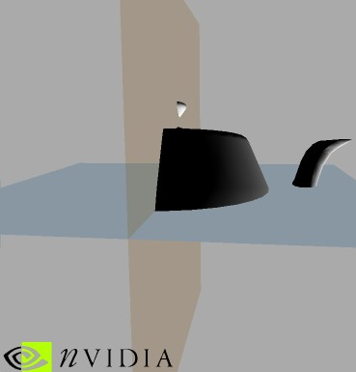

Clip-Planes with Texkill
This shader implements clipping-planes using texkill. A vertex shader first generates 2 clip planes and stores these in 2 columns of a 4x4 matrix (up to 4 clip planes can be used per texture coordinate). A vertex shader transforms the incoming vertex coordinates by the clip plane matrix. This effectively generates x & y values which will be less than 0 if the position is outside of the clip plane. The resulting x,y,z,w value is loaded into a texture coordinate and iterated across the polygon. Later, the pixel shader will discard any pixels that lie on one side of the plane.

Demonstrates:
Texkill, special texture coordinate generation, per-pixel clipping

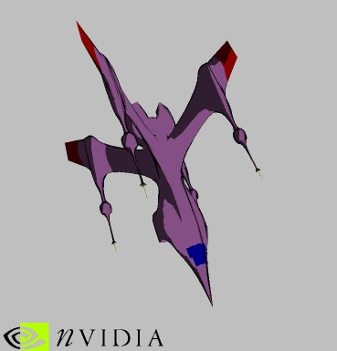

Toon Shading

This vertex shader computes L dot N and E dot N per vertex and uses the resulting values to index into two 1D textures. The L dot N computation is used to generate cartoon-like three-tone shading (shadowed, lit, highlighted), and the E dot N is used to darken silhouettes.

Just using E dot N for silhouettes can result in over-darkening of flat regions, so this demo varies the texture indexed by E dot N over its mip levels, resulting in darkening only for the edge-on pixels which access the higher mip levels.

Demonstrates: Custom texture coordinate generation
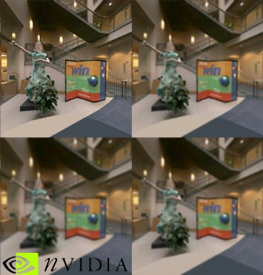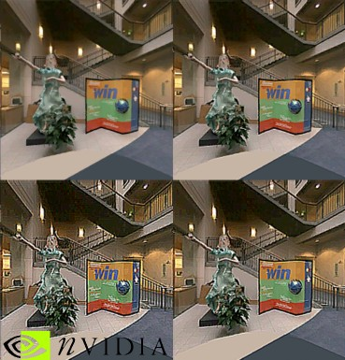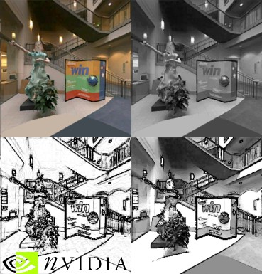

Filter Blitting

This shader shows how to filter-blit a texture in DirectX 8. The texture to filter is set as the active texture for all four texture-units. A vertex shader shifts the texture coordinates of a simple screen-spanning quad to achieve the desired (bi-linearly interpolated) texel sampling-points, before a pixel shader finally combines these four texel-samples. The screen shows the original texture in the upper-left corner, and applying the filter once, twice, and three times in the upper-right corner, lower-right corner, and lower-left corner, respectively. The luminance-based edge detection is different in that it shows partial results: upper-right corner shows the luminance-converted texture, lower-left corner shows the result of the edge-detection and the lower-right corner shows the final result of 2xModulating edges and luminance.

In addition to the luminance-based edge-detection, the following filters are implemented; each filter is a single pass operation (the filter kernels are displayed above the name):
¹/₁₆
¹/₈
¹/₁₆
¹/₈
¹/₄
¹/₈
¹/₁₆
¹/₈
¹/₁₆
¹/₉
¹/₉
¹/₉
¹/₉
¹/₉
¹/₉
¹/₉
¹/₉
¹/₉
¹/₁₆
¹/₁₆
¹/₁₆
¹/₁₆
¹/₁₆
¹/₁₆
¹/₁₆
¹/₁₆
¹/₁₆
¹/₁₆
¹/₁₆
¹/₁₆
¹/₁₆
¹/₁₆
¹/₁₆
¹/₁₆
4
-1

-1 -1

9-sample cone filter 9-sample box filter Sharpening Filter
(the filter kernel may 16-sample box filter
be arbitrarily rotated)
The menu options allow switching between the various filter-types and rendering in wire-frame.

Demonstrates: Render to texture; filter-blitting textures using the GPU; how to implement cone-, box-, and sharpening-filters using the texture-units bilinear filtering-unit and pixel-shaders.

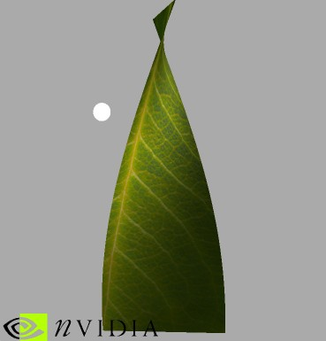

Two-Sided Texturing

This shader demonstrates correct lighting of a single-surface object viewed from the front or back, as well as a technique for applying different textures to the front and back faces of an object. If the single-sided object were to be lit by the standard TnL pipeline, incorrect lighting would result as the strip twists to expose its back side. Only one normal can be specified per vertex, and the back sides require a different normal than the front, a normal which points in the opposite direction. As the single specified normal twists away from the viewer, lighting would go to zero which is not correct for the geometry of the single-sided object. A vertex shader program is able to correct the back-facing normals and light the twisted strip correctly. The vertex shader also writes an alpha value to the vertex color based on whether the light is in front or behind the object relative to the camera, so the shading can mimick a thin transparent object with a different appearance (a different texture) for reflective light versus transmitted light.

Demonstrates: Vertex shader for single-sided objects; Vertex shader virtual branching; Multitexturing for more interesting materials; Pixel shader

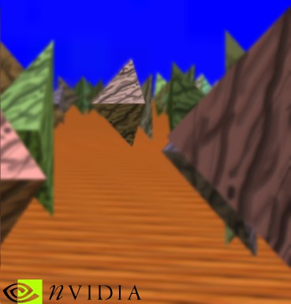

Depth of Field

This demo allows control over several camera parameters (camera position, camera orientation, focal length, focal distance, and f-stop) and renders the scene according to those parameters. In particular, it approximates depth-of-field, i.e., it renders objects that are in focus sharply, and objects that are out-of-focus blurred, yet runs in real-time.
The effect renders the scene only once. During this rendering vertex-shaders compute the per-vertex distance to the camera. This distance gets interpolated per-pixel and an associated pixel-shader transforms this distance into a “blurriness-interpolator” that is stored in the frame-buffer’s alpha-component. The frame-buffer is then filter-blitted multiple times to generate blurred versions. Finally, based on the “blurriness-interpolator” stored in the alpha-component we blend between the original in-focus frame-buffer and its various blurred versions to derive the final result. This technique is very similar to the algorithm described by M. Potmesil and I. Chakravarty in “A lens and aperture camera model for synthetic image generation,” Computer Graphics (Proceedings of SIGGRAPH 81), 15 (3), pp. 297-305 (August 1981, Dallas, Texas).
The “blurriness-interpolator” is looked-up in a texture. This texture is currently parameterized by distance to camera, and focus distance. Thus, when changing the f-stop this texture is regenerated. If f-stops change frequently one could re-parameterize the texture accordingly. Alternatively, one can operate on a 1D texture (parameterized by distance to camera only) and regenerate it every time any of the other parameters change – since this 1D texture would be of size ~1kB performance should be real-time.
This demo was inspired by an mpeg-trailer for a car-racing game. The trailer used in-game video-footage that was post-processed to add depth-of-field to make the visuals more dramatic. The technique shown here runs in real-time and applies to all racing-games that have a replay-option once the race is over. The many cameras used in replay-mode would become more dramatic if depth-of-field effects were applied to them.

The menu options allow rendering in wire-frame, to view the per-pixel distance-to-camera, or to visualize the amount of blurriness. Left-click-hold and moving the mouse controls the camera’s view-direction, and the arrow-keys move the camera forward, backward, left, and right. The keys I and O zoom in and out (i.e., change focal-length); U and P change the focus-distance, and K and L change the f-stop.

Demonstrates: Render to texture; blurring an image by repeated filter-blitting on the GPU; generating a depth-of-field effect.

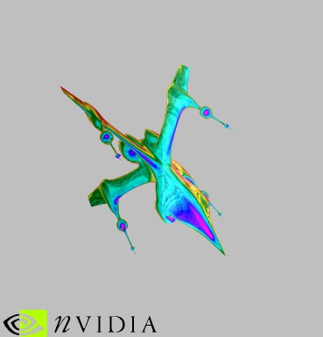

Rainbow Rendering

This demo uses some ideas from Toon Shading ( see above ) to create texture coordinates for each vertex using a vertex shader, based on the Half angle vector, a light and eye vectors, and the surface normal. Two samples are grabbed from the same texture and combined to create a rainbow iridescent effect.

Demonstrates : Vertex Shader, Multi-texturing

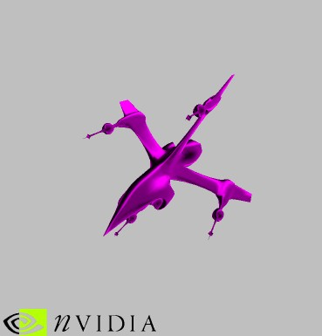

Anisotropic Rendering

Similar to the Toon shader and the Rainbow Rendering, this example uses a vertex shader to find edges and map them into a texture. It uses ideas from Anisotropic rendering to calculate H dot N for one axis of a texture and L dot N for the other axis. The texture contains a bright diagonal area where H dot N and L dot N are equal to simulate a velvet effect.

Demonstrates : Vertex Shader, Multi-texturing, Anisotropic Lighting

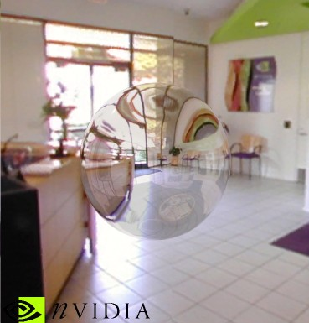

Single Pass Reflection and Refraction

This shader demonstrates how to generate two sets of texture coordinates for use with environment cube maps in order to produce a combined reflection and refraction effect in a single pass. The input normal vector and the input vertex are first moved into world space, with the normal being normalised to account for world transform scaling. The world space eye (passed as a constant) is used to calculate a world space eye-vertex vector, which is then used to calculate the reflection and refraction vectors. The refraction effect is approximated by shortening the normal and passing it through the standard reflection calculation. These vectors are loaded into the texture coordinates for use by the rasterizer in drawing the reflected/refracted object with a cube map. The blend between the reflection and refraction is controlled by the D3DRS_TEXTUREFACTOR renderstate and the D3DTOP_BLENDFACTORALPHA texture blend op. As can be seen, the object accurately reflects and refracts its surroundings convincingly.

Demonstrates: Texture generation for cubic environment map reflection and refraction

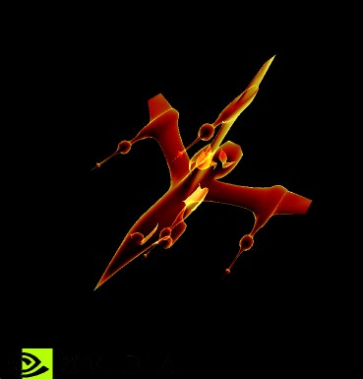

Membrane lighting

A thin partially scattering transmissive membrane is more visible when held at an angle than when viewed flat on to the surface. Plastic films, jellyfish, and other transparent marine life demonstrate this effect. For this example, we use a vertex program and 1D texture to vary the light contribution from a surface as its angle to the viewer becomes more or less steep. This method of rendering produces some interesting effects and is also useful in CAD or data visualization. Try loading various .x file models and your own custom textures.

Demonstrates : Vertex shader; Advanced transparency; Visualization technique

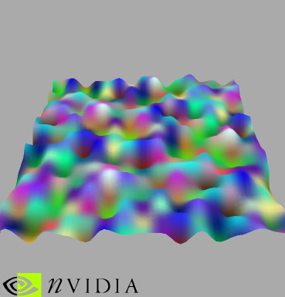

Perlin Noise Generation

This shader generates a vertex offset for each coordinate based on a noise calculation. The noise is calculated based on a permutation table stored in the constant memory. The style of noise is similar to Perlin noise. The resulting offset is used to distort the patch and setup the color of the vertices. Pressing the PAGEUP/PAGEDOWN and the UPARROW/DOWNARROW keys modify frequency and amplitude.

Demonstrates :
Generating noise in a vertex shader

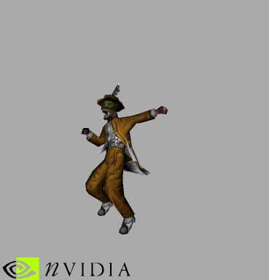

Keyframe Interpolation

These two examples show two methods for doing keyframe interpolation in a vertex shader. The first one simply does linear interpolation of the vertices, similar to the dolphin demo. The second blends between four keyframes using a hermite spline blending function (also called Catmull-Rom Spline) to achieve a smoother animation effect.

Demonstrates : Vertex blending, multiple vertex streams

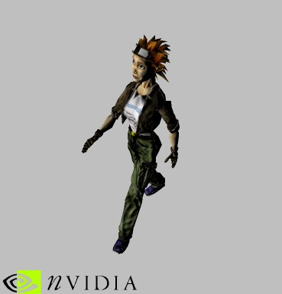

Matrix Palette Skinning w/ Dot3

This shader performs matrix palette skinning with dot3 setup. Each vertex has two indices which reference the two bones in constant memory which influence this particular vertex, along with the weights of influence. We calculate the vertex position in world space as influenced by each bone (so, two separate positions are generated per vertex) and then we blend between these two positions according to the weights to generate the final vertex position in world space.

A per-vertex local texture space basis is also passed into the shader as texture coordinates, and then each of this basis’ vectors (all three of them) are skinned and blended just as the vertices are. We then transform the light vector (passed in through the constant memory) into local texture space by using this skinned basis, and output the local light vector through diffuse color. The texture stage states then calculate NormalMap dot LightVector modulate DecalTexture.

Demonstrates: Dot3 setup, indexed matrix palette skinning

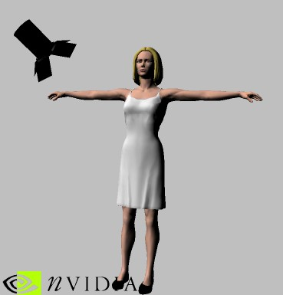

Minnaert Lighting

Minnaert Lighting is a form of BRDF which models subtle darkening effects, such as those in velvet. This demo uses the vertex shader to place the eye vector (E), the normal (N), and the light vector (L) in iterated texcoords and uses the texm3x2pad and texm3x2tex pixel shader instructions to use these texcoords to index into a texture map containing the minneart lighting values.

Demonstrates : texm3x2 pixel shader instruction, normalization cube maps
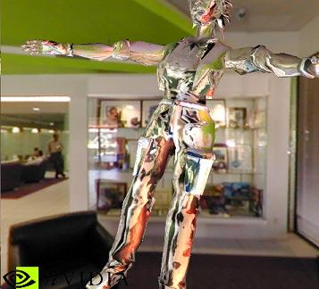

NVLINK 1.0

NVLINK is a tool that enables developers to create complex vertex shaders from shader ‘fragments’. First, the developer creates small pieces of vertex shader code to solve common problems, such as “create_eyespace_eyevector”. These files of fragments are assembled by NVASM to form fragment files, which are loaded by the linker. During game execution an application can then request combinations of fragments, which are returned as D3D shader op-codes. In this way, a developer can create many different shaders from a set of smaller fragments.

The demo, under “Tools\NVLink Vertex Shader Combiner”, uses NVLINK to create shaders based on the user input. The dialog box enables the user to set the number of lights (point and directional), where the lighting calculations are done (eye space/world space), and if the lights are specular or not. Additional options are available for texture coordinate generation for traditional cube mapping, and the more complex blinn bump mapping setup (requiring pixel shader support). The demo requires a minimum of a GeForce class card to run in hardware. It will also run on the Reference Rasterizer, but very slowly. When a shader is created, it is shown in the output pane, so you can see the shader that was generated for the current scene, and the number of registers, instructions and constants that it took.

The default setup for the demo shows a figure, ‘Tiny.x’, from the SDK, with per-pixel reflections and several lights. See the Linker Demo directory for more information on NVLINK.

Demonstrates :
Using NVLink to create various shader combinations
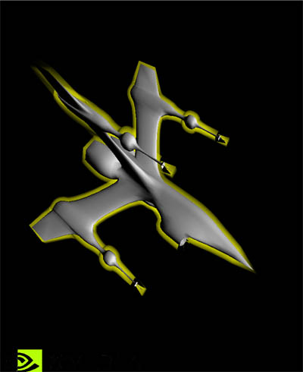

Silhouette Rendering

This demo shows a two-pass technique for rendering silhouettes around objects. The basic technique involves rendering the object once with depth-buffer writes disabled, using a vertex shader that extrudes each vertex along the vertex normal. Then, we render the object again, this time normally. This causes only the outline of the first rendering to be visible, resulting in an accented silhouette.

The halo effect is achieved by changing the alpha value dependent on E dot N, so vertices which are nearly edge-on are blended more.
The toon effect is done by simply doing the first rendering using a constant color.

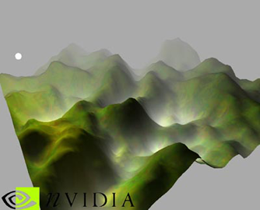

Simple Fog Example

This example renders a fogged landscape with two types of fog. It shows the interaction of fog calulations with pixel and vertex shader programs.

The first fog factor is a traditional screen depth based fog, calculated from the Z component of the vertex after the model-view-project transform. This value is written to the shader oFog.x which is used in a blending stage after the pixel shader program.

The second fog term is based on the model space landscape height and appears as the white fog in the valleys. You can change the scaling of this second term with the “<” and “>” keys. The value is passed into the pixel shader program, where it is added to the base texture color.

The landscape height is generated as the sum of three blurred and scaled random noise fields. The blurring produces features of varying roughness, and the more blurred components are added in with a greater scale factor.

Demonstrates: Fog with vertex and pixel shaders, landscape generation

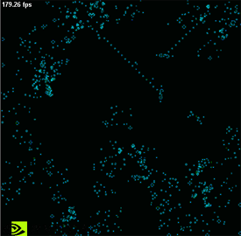

Game of Life

This effect demonstrates Conway’s Game of Life running in pixel and vertex shader programs on the GeForce3. This game is one of a class of cellular automata (CA) programs which animate pixels (cells) based on their local environment within the image. The technique is useful for generating proceedural textures and texture animations which require very little storage space or video memory. Some of the impressive effects in Unreal are generated by similar algorithms, and we plan to develop other CA examples for water, fire, and smoke effects.

The patterns can tile automaticaly (hit ‘B’, then ‘3’ to see this in the demo) by enabling texture wrapping.

For this example, the logic required to produce the next generation requires three render-to-texture passes, and involves a dependent green-blue texture lookup (D3D’s texreg2gb instruction) in the final pass. An 8x2 texture encodes the rules of the game. You can modify this Rules.bmp to be any power of two size with whatever colors you like. A few rules maps are provided.

Demonstrates: Cellular automata, render to texture, texture animation

